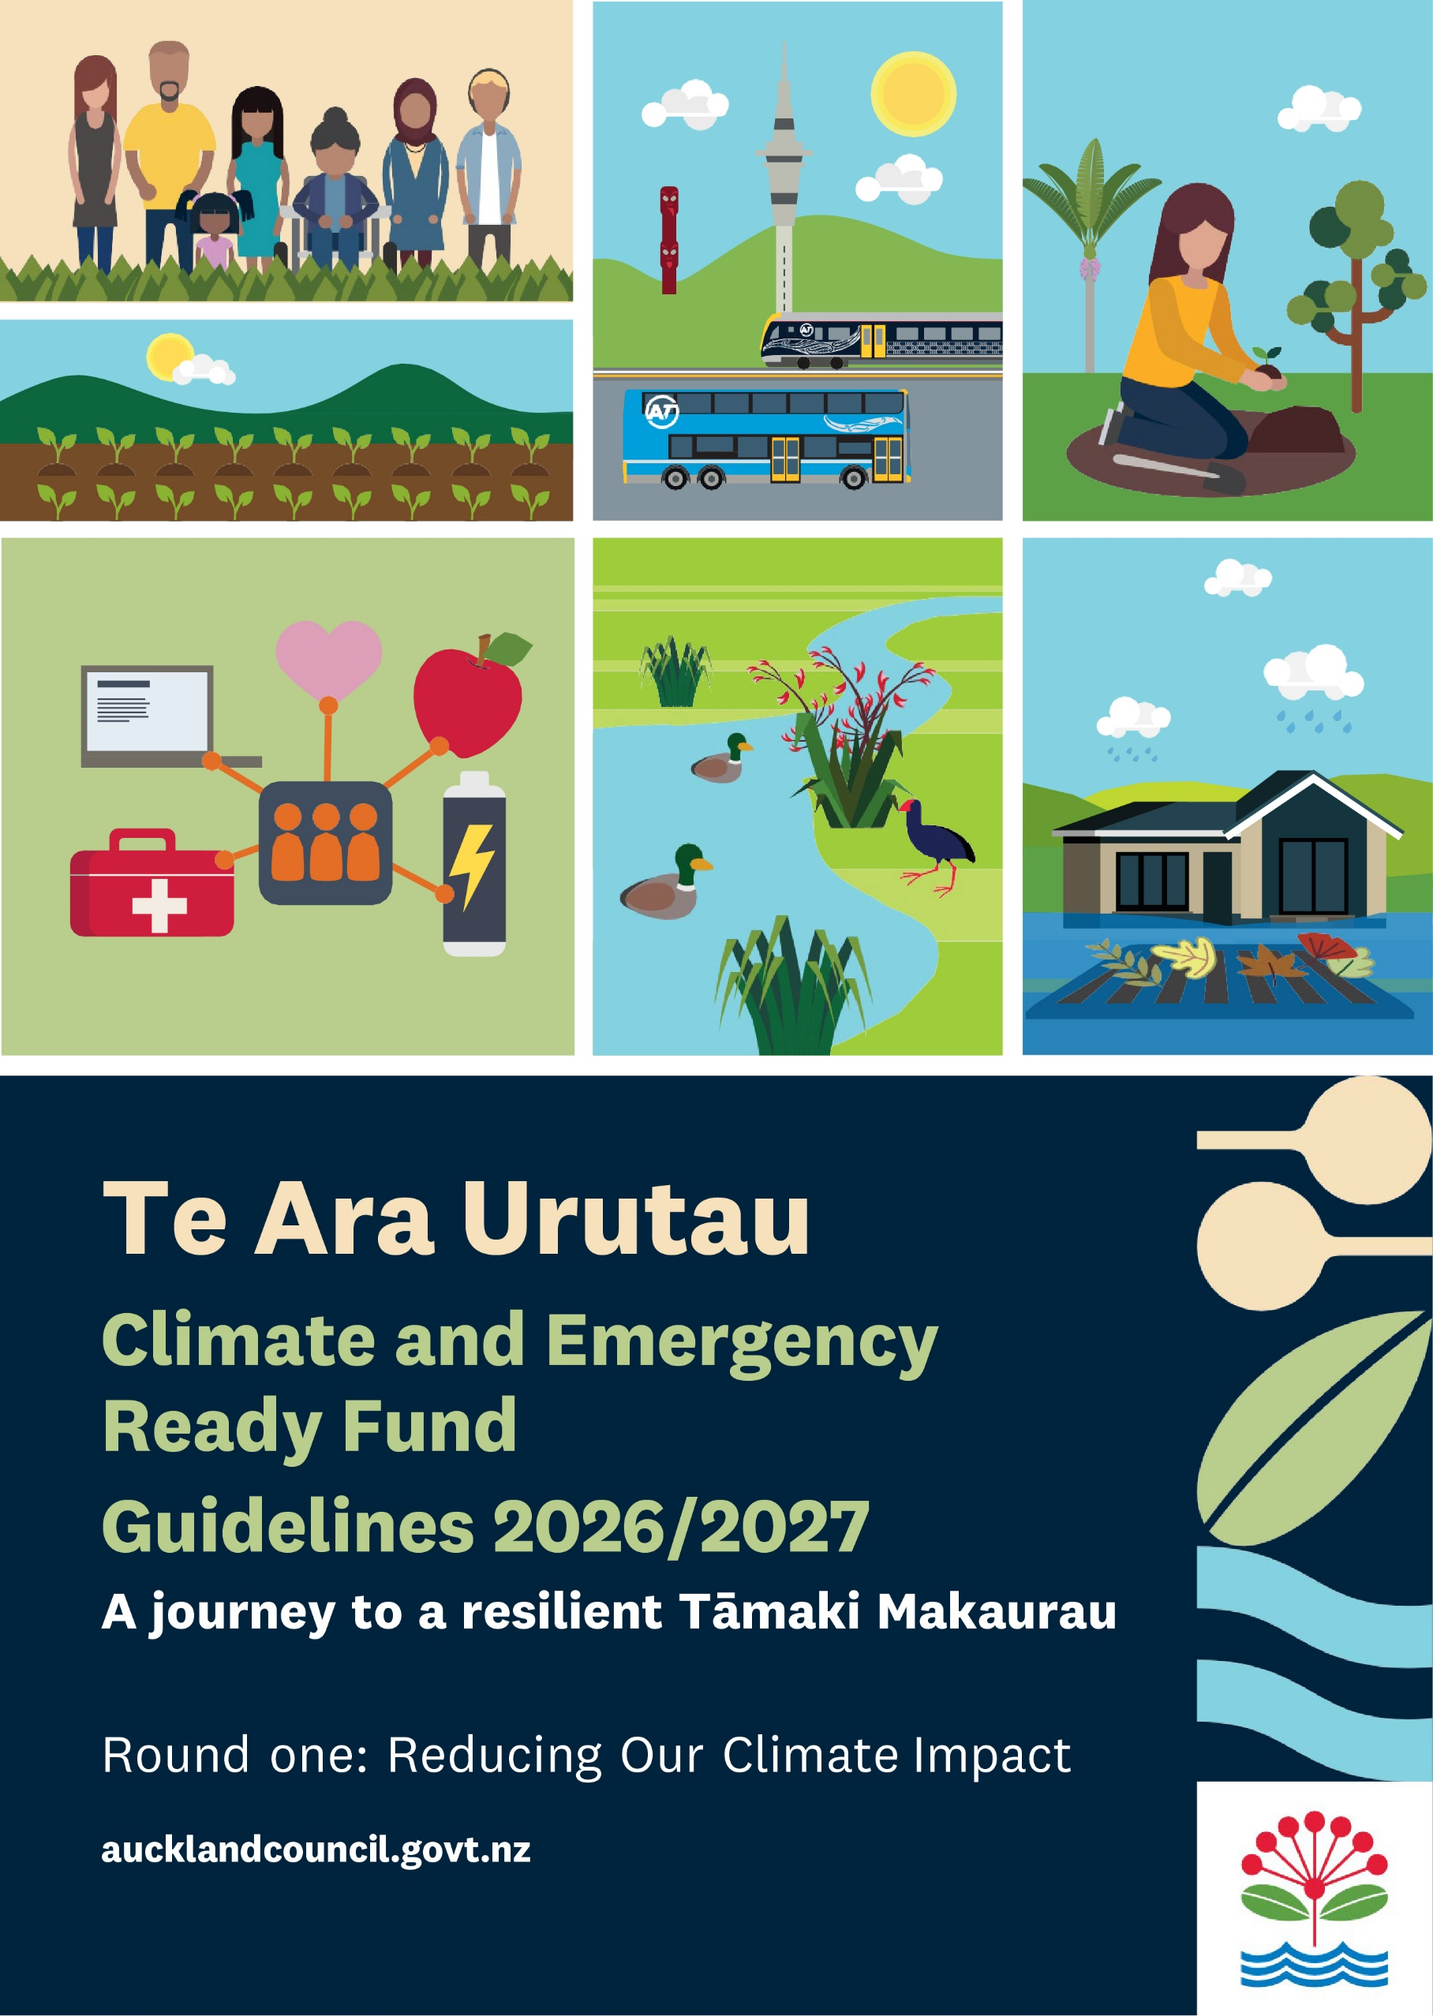

Contents
Fund overview 3
Eligible project categories for Reducing Our Climate Impact funding round 4
Eligibility 5
Key dates 5
Prioritising risks and impact 6
Activities not eligible 6
How to apply 7
Assessment and funding decisions 7
Reporting 7
Round two Community-led Adaptation and Emergency Preparedness opens 25 January 2027 8
Getting in touch 9
Appendix 1: Reducing our Climate Impact measures and reporting requirements 10

Fund overview

By working together, we will keep the people and places we love safe from climate disruption and emergency events.
This contestable fund programme is designed to support community organisations and their partners to take bold action today to reduce emissions and prepare for climate change impacts and emergencies. Funding can support communities wherever they may be in their journey - from learning about emissions and how to reduce them, to preparing for emergencies, and taking the first steps to define and implement community priorities and long-term actions to adapt to climate change.
For the 2026/2027 financial year there is a total of more than $1,700,000 available through two focused funding rounds.
Round one: Reducing our Climate Impact
This round is focused on supporting community-led and Māori-led projects that reduce carbon emissions. Approximately $380,000 is available to support projects that promote sustainable food, energy, transport solutions and community participation in climate action.

Open
12 October 2026
Close
16 November 2026
Funding decisions
4 March 2027

Round Two: Community-led Adaptation and Emergency Preparedness
In total this round has approximately $1.4 million available across two categories focused on supporting:
- Climate Adaptation Planning and Implementation: Enabling community-led planning and action to respond to climate disruptions such as flooding, sea-level rise, heat and drought

- Emergency Readiness and Response: Helping communities work together to prepare for natural disasters and extreme weather events, strengthening local resilience before emergencies happen.
Through one application to this round, you can apply for both adaptation and emergency preparedness categories.

Open
25 January 2027
Close
22 February 2027
Funding decisions
27 May 2027

This guideline document is for Round one: Reducing our Climate Impact. Additional guidance for Round Two: Community-led Adaptation and Emergency Preparedness will be available in December 2026.

Eligible project categories for Reducing Our Climate Impact funding round

Reducing our Climate Impact: Grants $5,000 - $50,000

Transport
Projects that support low carbon, safe transport systems that deliver social, economic and health benefits for all. This includes innovative solutions that reduce the need for travel such as:
- education, events and resources to encourage the use of public transport, walking, bicycles, e-bikes or electric scooters, rather than driving
- improving access to communal and personal bicycle, e-bike or electric scooters within under-served communities including bike hubs and bike loan programme
- improving access to co-working spaces supporting people to work locally and avoid travel.
Projects should include

Food
Projects that support a low carbon, resilient, local food system that provides all Aucklanders with access to fresh, sustainable, affordable and healthy food and that support Aucklanders to make sustainable dietary choices. Projects prioritized
- supporting communities to increase plant-based meals and therefore reducing emissions;
- supporting food growing projects such as community gardens may be supported if they have planned activity for education and behaviour change towards plant-based meals, as well as a framework for evaluating the impact
- increasing soil sequestration may be supported
- regenerative practices such as improving soil health may be supported if they have a scientific method of demonstrating the improvement
- indigenous food systems and projects underpinned by Mātauranga Māori and/or are Māori designed and led, as well as other food growing projects that help groups reconnect with their indigenous food traditions.

Energy
Projects that support a built environment and energy system that provides for a low carbon, climate disaster-resilient Auckland. This could include:
- education and events to encourage the uptake of more efficient energy use by communities, use of renewable energy, and reduction in power costs for low-income Aucklanders;
- education, events and resources to support retrofitting of non-Council community facilities such as community halls, marae or places of worship;
- supporting Aucklanders to reduce energy consumption.
Note: applications for solar are generally supported in specific circumstances related to geographic isolation and/or transition off existing fossil fuel generated energy. Please contact Council staff to discuss before applying.

Community Participation
Projects that grow Aucklander’s participation in local climate action projects with a focus on priority community groups. This could include:
- Education, events, networks and resources to increase Aucklanders’ participation in local climate action projects.
- Skills development for communities related to climate action, including carbon literacy, bike maintenance, cooking demonstrations and home energy efficiency.

Eligibility
Applications from the following types of community groups are invited. Please note, groups may only submit one application per round.
- community groups, including not-for-profit, charitable and voluntary organisations Mana whenua and Māori organisations
- neighbourhood or resident groups*
- two or more schools working together to lead community projects
- business improvement districts, associations or social enterprises delivering projects community/public benefit**

*Established not-for-profit organisations can support groups who are not incorporated, are unregistered or new by acting as the “umbrella” fundholder for any approved funding. Please contact us if you need support with this.
** Social enterprises will be asked to provide detail on the community/public good focus of their organisations

Key dates

Round one Reducing Our Climate Impact

Round One Reducing Our Climate Impact application period opens 12 October 2026

Support available for applicants: Council staff will host a webinar on Tuesday 20 October 2026 at
12:00pm-1:00pm to give an overview of grants available, application process and answer general questions.
Please register Microsoft Virtual Events Powered by Teams for the webinar or contact us funding@aucklandcouncil.govt.nz for questions.

Applications due Midnight 16 November 2026

Notice of decisions By or before 11 March 2027

Projects begin Funding agreements are anticipated to start by 1 April 2027 or sooner.

Round two Community-led Adaptation and Emergency Preparedness opens 25 January 2027

Prioritising risks and impact

All applications should outline how the project(s) will benefit their community, people and places that are at significant risk to climate change and emergencies, or significantly reduce GHG emissions.
Depending on your community and project(s), this may include projects that focus on some or all of the following:

- seniors and youth
- refugees and recent migrants
- residents who are disabled people
- geographically isolated communities
- Rainbow communities
- people from diverse cultures and languages communities
- Māori or Pasifika communities
- communities most vulnerable to climate change including flooding, sea level rise and heat

Across all project categories above, diverse partnerships as well as Māori-led projects supporting mana whenua and mātāwaka are highly encouraged.

Māori-led projects are those that:
- provide activities or opportunities for Māori hapū, iwi, marae or other Māori communities to build community resilience to climate impacts and be emergency ready
- have a foundation in Te Ao Māori philosophy and principles, mātauranga Māori and/or apply Māori language
- the applicant groups or project leaders are predominantly Māori.

Activities not eligible

The following activities are not eligible to be funded by this Council grant programme:

- programmes delivering benefits primarily outside of Tāmaki Makaurau, or have a primary purpose focused on private/individual gain rather than overall public benefit/good
- physical works without a permit (if construction is to be undertaken during the grant term)
- public services that are the primary responsibility or duplicative of government, or projects that are more closely aligned with other Council grant funding opportunities
- debt servicing or repayment, promotion of religious ministry, political or fundraising purposes legal, medical expenses, purchases of alcohol or vehicles or vehicle-related expenses retrospective funding i.e., programmes or work that has already been delivered
- subscription services or ongoing costs not associated with a project-specific event or outcome
- projects that are primarily research-focused and not community-based.

How to apply

The link to the application form will be live on 12 October 2026 to midnight 16 November 2026. We will provide a link at this time.

The application form is intended to capture the following overall information about your organisation, community and project(s):
- applicant details and budget
- programme/project goals and expected outcomes community need for and engagement in this project alignment with funding priorities of this grant programme

Grants for Reducing Our Climate Impact are available for both small-scale project delivery and larger strategic regional projects.

For funding requests over $15,000 projects should have a tangible or clearly quantifiable impact on community participation and climate emissions reduction. Applicants will be asked for additional information on project planning, monitoring and evaluation of their project as part of the application.

Assessment and funding decisions

All eligible applications will be assessed against the below criteria. Assessment will be conducted by a panel of Council staff with final recommendations made through combined scoring processes and endorsed by the relevant decision-makers.
- Alignment of project(s) with these grant guidelines (scope and eligible project categories, etc.).
- Likelihood of success based on factors such as your organisational capacity, planned activities, budget and project sustainability.
- Māori outcomes supported through Māori leadership and/or engagement or partnerships.
- Community impact and engagement, demonstrated through communities served and risks addressed, collaboration and partnerships, and overall equity of communities served.
- Overall project impact, reach and innovation to meet unmet community needs.

Reporting
Reporting helps Council learn about your project, share great stories of community action and support effective use of public funds. Reporting required will be specified in the funding agreement. We will work with you to find a reporting method that captures your story and project outcomes effectively, which may include written report(s), videos, case studies, presentations, maps, graphs or a mixture of different formats

Round two Community-led Adaptation and Emergency Preparedness opens 25 January 2027

In total this round has approximately $1.4 million available to support either or both of the following:
- Community Climate-led Adaptation Planning and Implementation: Enabling community-led planning and action to respond to climate challenges such as flooding, sea-level rise, heat and drought.
- Emergency Preparedness: Helping communities work together to prepare for natural disasters and extreme weather events, strengthening local resilience before emergencies happen
Guidelines for Round Two Community-led Adaptation and Emergency Preparedness will be available in December 2026. High level information on the types of projects supported in this round is provided in the image below. More information on these projects is to come.

Emergency Readiness and Response

Projects will include

Workshops, tools, resources or events to inform Aucklanders about emergencies and hazards and inspire preparedness action in their homes, workplaces and communities.

Street meets, events and innovative engagement to build community networks, cohesion, and strengthen communication channels needed among neighbours in disaster.

Support all our diverse community members to be emergency ready such as those who may have disabilities, are isolated or with diverse languages and cultures.

Supporting existing community emergency hubs or marae to purchase resources that will increase their emergency readiness (conditions will apply).

Climate Adaptation Planning & Implementation

Community-led planning proposals should

- Resources, events and wānanga to build community understanding of local climate impacts and actions we can take to be climate-ready.
- Identify and prioritise adaptation actions through community planning that families and whānau, organisations and community can take to adapt to climate impacts
- Build and diversify networks of stakeholders engaged, ensuring that everyone who wishes to, has an opportunity to contribute.
- Take tangible community actions to adapt to climate change as part of the planning process (planting shade trees, reduce water and energy use).

For those with a plan, your implementation may
- Avoid putting more people, taonga, homes, and community spaces in harms way, and make space for nature in hazard areas
- Accommodate: Adjusting our places and practices to a changing climate, by restoring wetlands, adapting farming, or designing spaces to be future-proof.
- Protect places we love through action, such as preventing erosion, replacing concrete with nature and permeable surfaces, building swales to manage water.
- Retreat: Develop a community vision for moving people, taonga and community assets to safe ground; contract expert help to investigate most challenging solutions.

Getting in touch

For additional questions or assistance with the grant programme or application, please contact: funding@aucklandcouncil.govt.nz

Appendix 1: Reducing our Climate Impact measures and reporting requirements

Use this appendix to identify the information relevant to your proposed project.

Why identifying your measures matters: Auckland Council funding represents an investment of public funds, making it important to clearly demonstrate what funded projects achieve. Identifying the relevant measures when preparing your application will help you plan for and collect the right information from the outset, demonstrate your project’s contribution to climate action and meet the accountability requirements if your application is successful.

Information all funded projects need to report
Regardless of the climate-action theme, all funded projects must report the information below. Additional reporting will depend on the focus and activities of the project

Standard requirement Project information
Information to report: Project title, Actual start and end dates, Local board area(s), Project or activity location
How to prepare or evidence it: Keep the application, funding agreement and core project records up to date.

Standard requirement: Project expenditure
Information to report: Total grant amount spent, Itemised expenditure description and value, Evidence of grant expenditure
How to prepare or evidence it: Keep receipts, invoices, bank statements or other suitable evidence.

Standard requirement: Activities and participation
Information to report: Number of volunteers/participants, Total volunteer hours, Number of workshops, events or open days delivered, Activity descriptions and attendee numbers, Participant feedback, where available
How to prepare or evidence it: Use activity logs, attendance records, registration records, sign-in sheets, volunteer logs or timesheets

Standard requirement: Project delivery and contribution
Information to report: Activities completed and the difference the funding made, Changes to the original project plan, Contribution to reducing emissions and/or building resilience
How to prepare or evidence it: Keep brief progress records and record material changes, assumptions and results as the project proceeds.

Standard requirement: Collaboration and Māori outcomes
Information to report: Groups or organisations involved in delivery, Contribution to Māori outcomes, where applicable
How to prepare or evidence it: Keep relevant partnership, engagement or delivery records

Standard requirement: Highlights and learning
Information to report: Project highlights, What was learned and what would be done differently
How to prepare or evidence it: Record key achievements, challenges and learning during delivery.

Standard requirements: Communication and evidence
Information to report: Project photos or short videos, Social media links, where available, How the project was promoted, How Auckland Council support was acknowledged
How to prepare or evidence it: Keep relevant photos, links and copies of communications. Confirm permission for Council use of supplied media.

Standard requirements: Additional information and declaration
Information to report: Any additional comments or supporting files, Permission to publish and share project data, Confirmation that the information supplied is correct
How to prepare or evidence it: Complete these items when submitting the project completion report.

Measures to consider for your climate-action theme

In addition to the general information above, identify the climate-action theme or themes your project will contribute to and review the relevant reporting measures below. More than one theme may apply. Only use the measures that are relevant to your proposed activities.

Climate action theme: Transport
Relevant indicators to consider: Funded transport activities completed and attendee numbers, Contribution to reducing transport emissions and/or improving climate resilience, Relevant participation, feedback, highlights, learning and supporting evidence
When to record After each relevant activity and at project completion
How to measure: Use activity and attendance records, participant feedback, photos or videos, and a clear explanation of the project’s contribution to emissions reduction and/or resilience

Climate action theme Energy
Relevant indicators to consider: Funded energy activities completed and attendee numbers, Contribution to reducing energy-related emissions and/or improving climate resilience, Relevant participation, feedback, highlights, learning and supporting evidence
When to record: After each relevant activity and at project completion
How to measure: Use activity and attendance records, participant feedback, photos or videos, and a clear explanation of the project’s contribution to emissions reduction and/or resilience.

Climate action theme Food
Relevant indicators to consider: Funded food-related activities completed and attendee numbers, Contribution to reducing food-related emissions and/or improving climate resilience, Relevant participation, feedback, highlights, learning and supporting evidence
When to record After each relevant activity and at project completion
How to measure: Use activity and attendance records, participant feedback, photos or videos, and a clear explanation of the project’s contribution to emissions reduction and/or resilience.

Climate action theme: Māori-led
Relevant indicators to consider: Māori-led climate activities completed and attendee numbers, Contribution to emissions reduction, climate resilience and Māori outcomes, Relevant participation, collaboration, feedback, highlights, learning and supporting evidence
When to record Throughout delivery and at project completion
How to measure: Use activity, participation and partnership records, participant feedback, photos or videos, and a clear explanation of the project’s contribution to emissions reduction, resilience and Māori outcomes.

Climate action theme Community
Relevant indicators to consider: Community climate activities completed and attendee numbers, Contribution to emissions reduction and/or community climate resilience, Relevant participation, collaboration, feedback, highlights, learning and supporting evidence
When to record After each relevant activity and at project completion
How to measure: Use activity, attendance, volunteer and collaboration records, participant feedback, photos or videos, and a clear explanation of the project’s contribution to emissions reduction and/or resilience

Important notes
- Use the reporting measures that are relevant to your project. Not every measure will apply to every project.
- If a measure relates to more than one theme, record the result once and explain the themes it contributes to.
- Where you estimate emissions reduction or resilience benefits, record the method, assumptions and source information used.
- If you are unsure which measures apply to your project, contact a council staff member before submitting your application. Email funding@aucklandcouncil.govt.nz

Questions about these requirements: Contact a council staff member using the contact details provided in the grant guidelines.

