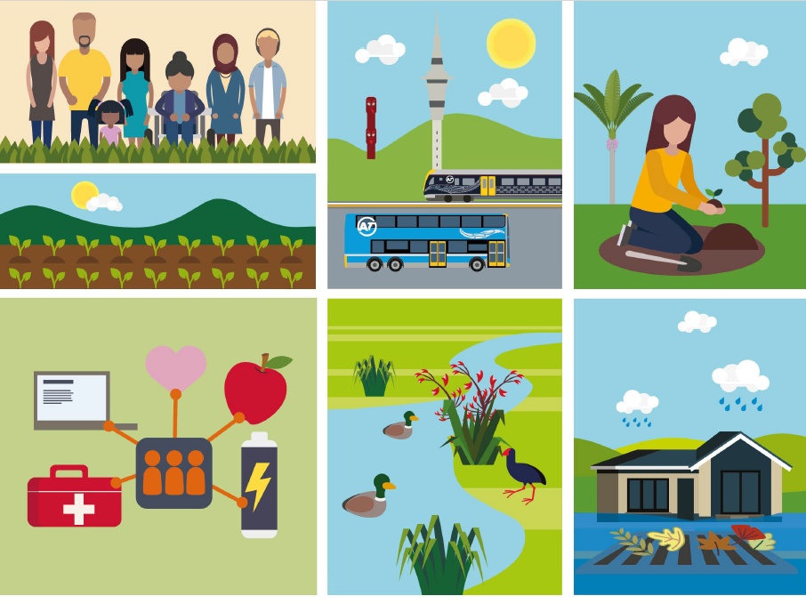

Te Ara Urutau

Climate and Emergency Ready Fund Guidelines
A journey to a resilient Tāmaki Makaurau
2025/2026 Funding Round
Auckland Council
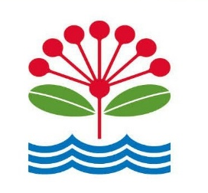

Contents
Contents 2
Grant programme summary 3
Eligible project categories 3
Eligibility 7
Key dates 8
Prioritising risks and impact 9
Activities not eligible 10
How to apply 10
Assessment and funding decisions 11
Reporting 11
Getting in touch 11
Appendix 12

Grant programme summary

By working together, we will keep the people and places we love safe from climate disruption and emergency events.
This contestable grant programme is designed to support community organisations and their partners to take bold action today to reduce emissions and prepare for climate change impacts and emergencies. Funding can support communities wherever they may be in their journey -- from learning about emissions and how to reduce them, to preparing for emergencies, and taking the first steps to define and implement community priorities and long-term actions to adapt to climate change. A total of more than $1,000,000 is available for this round, in what is anticipated to be an annual grant programme (subject to funding availability).

Eligible project categories
Communities and organisations can select up to two of the three following project categories to apply for:

Greenhouse Gas (GHG) Emissions Reduction - Maximum grant request: $15,000.
Programmes and activities to build community understanding and participation in climate action to reduce high emitting behaviours. Priority will be given to projects focused on food, transport, energy and community participation.

Emergency Readiness and Response - Maximum grant request: $15,000
Projects, activities and resourcing to promote emergency readiness and community preparedness for emergencies (e.g. earthquake, flood, tsunami, volcano, storms and extreme weather events).

Climate Adaptation Planning and Implementation
3.1 Community-led planning and action projects to understand climate hazards (e.g. flooding, sea level rise, heat waves, drought, ocean acidification), risks they pose to community, and prioritise options and test actions to adapt to them. Projects should include all or many of the components listed in 3rd column on the next page.
Maximum planning request: $40,000
3.2 Implementation funding for communities that have already developed a climate adaptation plan and/or have prioritised adaptation actions in a community process. Funding will support actions to prevent or reduce exposure to identified climate change impacts and hazards in your local area or community. Implementation activities will be unique to the hazards in and climate impacts in each community.
Maximum grant request: $175,000 total for a two-year grant
Grant requests must be a minimum of $5,000.
The following page further details each of the project categories and gives examples. These grant guidelines expand the existing Auckland Climate Grant Response round with additional funding and expanded eligible projects for communities preparing for emergencies and defining and implementing community priorities to adapt to climate change.

Climate Adaptation Planning & Implementation
1. Greenhouse Gas Emissions Reduction

Projects should include one or more:
2. Emergency Readiness & Response

Projects should include one or more:

      - Community-led planning proposals should
include all or most of the below:
      - For those with a plan, your implementation may
include actions to:

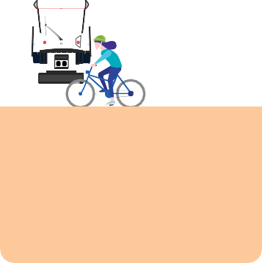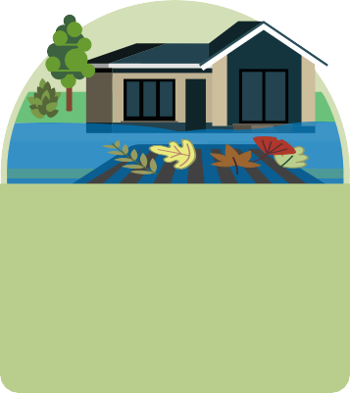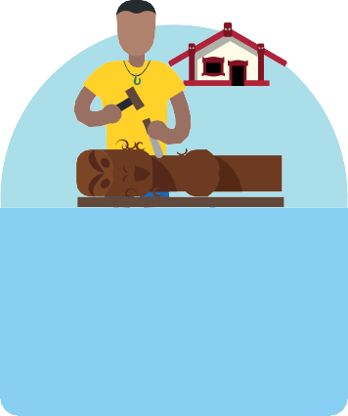

Promote public transport, walking, biking, e-bikes and other mobility options that reduce car trips.

Workshops, tools, resources or events to inform Aucklanders about emergencies and hazards and inspire preparedness action in their homes, workplaces and communities.

1. Resources, events and wānanga to build community understanding of local climate impacts and actions we can
take to be climate-ready.

Avoid putting more people, taonga, homes, and community spaces in harms way,
and make space for nature in hazard areas.
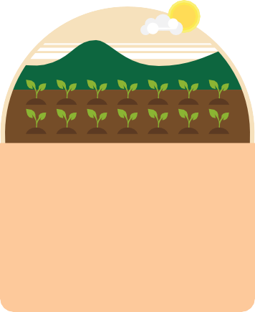







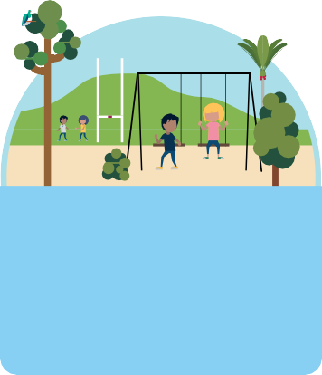
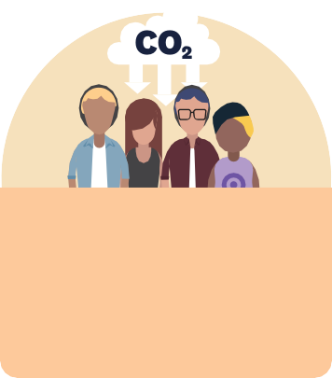


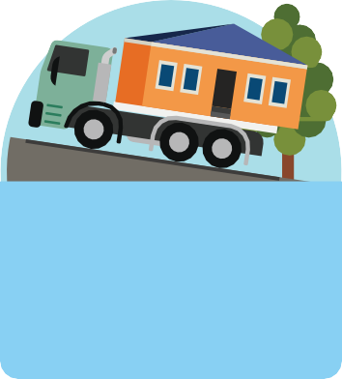

Food and food systems such as projects supporting sustainable diets or projects reconnecting communities with indigenous food growing traditions.

Street meets, events and innovative engagement to build community networks, cohesion, and
strengthen communication channels needed among neighbours in disaster.

2. Identify and prioritise adaptation actions through community
planning that families and whānau, organisations and community can take to adapt to climate impacts.

Accommodate: Adjusting our places and practices to a changing climate,
by restoring wetlands, adapting farming, or designing spaces to be future-proof.

Support all our diverse community members to be emergency ready such as those who may have disabilities,
are isolated or with diverse languages and cultures.

3. Build and diversify networks of stakeholders engaged, ensuring that
everyone who wishes to, has an opportunity to contribute.

Protect places we love through action, such as preventing erosion, replacing concrete with nature and permeable surfaces, building swales to manage water.

Increasing community participation in projects that reduce emissions, through events, education and community networks.

Resourcing existing community emergency hubs or marae with personal protective equipment or first aid supplies.
See note below for eligibility.

4. Take tangible community actions to adapt to climate
change as part of the planning process
(planting shade trees, reduce water and energy use).

Retreat: Develop a community vision for moving people, taonga and community assets to safe ground; contract expert help to investigate most challenging solutions.

Low carbon energy system projects including education and events encouraging uptake of renewable systems and retrofitting of facilities.

Note:

[Equipment and supplies are only for Community Emergency Hubs or Networks and Marae that are listed in the Local Board Emergency Readiness and Response Plans. Please select among established equipment and supplies pack option(s) which Council will deliver to your facility.]

[The text in the chart on the prior page (5) is also included as text in an appendix at the end of this document to ease use with assistive technology.]

Eligibility
Applications from the following types of community groups are invited.
        - community groups, including not-for-profit, charitable and voluntary organisations
        - mana whenua and Māori organisations
        - neighbourhoods or resident groups*
        - schools leading community projects
        - business improvement districts, associations or social enterprises delivering projects community/public benefit
*Established not-for-profit organisations can support groups who are not incorporated, are unregistered or new by acting as the “umbrella” fundholder for any approved funding. Please contact us if you need support with this.
Applications with evidence of partnerships with community members and other organisations are encouraged. In order to support a variety of communities across Auckland, in line with their needs, applications can be for a maximum of two of the three eligible project categories (GHG emissions reduction, emergency preparedness, or adaptation planning and implementation) using the same application form.
No single organisation can lead an application for all three categories (unless they are serving as an umbrella organisation). Organisations are encouraged to partner to support applications by others.
Applications should be based on their community priorities, and capacity to complete the project. Those applying for multi-year funding to implement climate adaptation plans will be asked to submit their existing plan as part of their application.

Key dates

Stage | Provisional Timeline
Application period opens | 2 February 2026
Support available for applicants | Council staff will host a webinar on Thursday 5 February 2026 at 11:30am-12:30pm to give an overview of grants available, application process and answer general questions.  Please register here for the webinar, or contact us funding@aucklandcouncil.govt.nz for questions.
All applications due | 8 March, 2026
Notice of decisions | By or before end of May 2026
Projects begin | Funding agreements are anticipated to start by July 1, 2026 or sooner.

Prioritising risks and impact
All applications should outline how the project(s) will benefit their community, people and places that are at significant risk to climate change and emergencies, or significantly reduce GHG emissions. Depending on your community and project(s), this may include projects that focus on some or all of the following:
- seniors & youth
- refugees & recent migrants
- residents with disabilities
- geographically-isolated communities
- Rainbow communities
- people with diverse cultures and languages
- Māori or Pasifika communities
- Communities most vulnerable to climate change including flooding, sea level rise and heat

Across all three eligible project categories above, diverse partnerships as well as Māori-led projects upporting mana whenua and mātāwaka are highly encouraged. Māori-led projects are those that:
- provide activities or opportunities for Māori hapū, iwi, marae or other Māori communities to build community resilience to climate impacts and be emergency ready
- have a foundation in Te Ao Māori philosophy and principles, mātauranga Māori and/or apply Māori language
- the applicant groups or project leaders are predominantly Māori

Activities not eligible
The following activities are not eligible to be funded by this Council grant programme:
- programmes delivering benefits primarily outside of Tāmaki Makaurau, or have a primary purpose focused on private/individual gain rather than overall public benefit/good
- physical works without a permit (if construction is to be undertaken during the grant term)
- public services that are the primary responsibility or duplicative of government, or projects that are more closely aligned with other Council grant funding opportunities
- debt servicing or repayment, promotion of religious ministry, political or fundraising purposes
- legal, medical expenses, purchases of alcohol or vehicles or vehicle-related expenses
- retrospective funding i.e., programmes or work that has already been delivered
- subscription services or ongoing costs not associated with a project-specific event or outcome
- projects that are primarily research-focused and not community-based

How to apply
The link to the application form will be live on 2 February 2026 to 8 March 2026. We will provide a link at this time. The application form is intended to capture the following overall information about your organisation, community and project(s):
- Applicant details and budget
- Programme/project goals and expected outcomes
- Community need for and engagement in this project
- Alignment with funding priorities of this grant programme

Assessment and funding decisions
All eligible applications will be assessed against the below criteria. Assessment will be conducted by a panel of Council staff with final recommendations made through combined scoring processes and endorsed by the relevant decision-makers.
- Alignment of project(s) with these grant guidelines (scope and eligible project categories, etc.)
- Likelihood of success based on factors such as organisational capacity, planned activities, budget and project sustainability
- Māori outcomes supported through Māori leadership and/or engagement or partnerships
- Community impact and engagement, demonstrated through communities served and risks addressed, collaboration and partnerships, and overall equity of communities served
- Overall project impact, reach and innovation to meet unmet community needs
We will notify applicants of the outcome of your application by phone or email. Successful applicants will receive a funding agreement outlining conditions of the grant and reporting requirements (see below). Groups must sign a funding agreement prior to being funded.

Reporting
Reporting helps Council learn about your project, share great stories of community action and support effective use of public funds. Reporting required will be specified in the funding agreement. We will work with you to find a reporting method that captures your story and project outcomes effectively, which may include written report(s), videos, case studies, presentations, maps, or a mixture of different formats.

Getting in touch
For questions or assistance with the application, please contact: funding@aucklandcouncil.govt.nz

Appendix

Note: The below content displays the text content from the chart on page five with aim to increase ease of use with assistive technology.

The below summarises each of the eligible project categories and gives examples or requirements for each category:

Greenhouse Gas Emissions Reduction
Projects should include one or more of the following:
- Promote public transport, walking, biking, e-bikes and other mobility options that reduce car trips.

- Food and food systems such as projects supporting sustainable diets or projects reconnecting communities with indigenous food growing traditions.

- Low carbon energy system projects including education and events encouraging uptake of renewable systems and retrofitting of facilities.
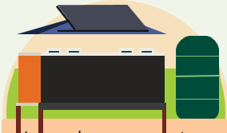
- Increasing community participation in projects that reduce emissions, through events, education and community networks.
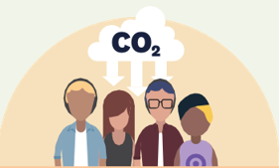

Emergency Readiness & Response
Projects should include one or more of the following:
- Workshops, tools, resources or events to inform Aucklanders about emergencies and hazards and inspire preparedness action in their homes, workplaces and communities.

- Street meets, events and innovative engagement to build community networks, cohesion, and strengthen communication channels needed among neighbours in disaster.

- Support all our diverse community members to be emergency ready such as those who may have disabilities, are isolated or with diverse languages and cultures.

- Resourcing existing community emergency hubs or marae with personal protective equipment or first aid supplies. See note below for eligibility for these supplies and equipment.
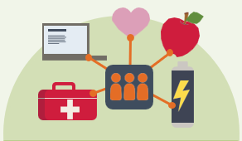

Note: Equipment and supplies are only for Community Emergency Hubs or Networks and Marae that are listed in the Local Board Emergency Readiness and Response Plans. For such hubs, networks and marae, please select among established equipment and supplies pack option(s) which Council will deliver to your facility.

Climate Adaptation Planning and Implementation

3.1 Community-led planning proposals should include all or most of the below elements:
- Resources, events and wānanga to build community understanding of local climate impacts and actions we can take to be climate-ready.

- Identify and prioritise adaptation actions through community planning that families and whānau, organisations and community can take to adapt to climate impacts.

- Build and diversify networks of stakeholders engaged, ensuring that everyone who wishes to, has an opportunity to contribute.

- Take tangible community actions to adapt to climate change as part of the planning process (planting shade trees, reduce water and energy use).


3.2 For those with a plan, your implementation may include actions to:
- Avoid putting more people, taonga, homes, and community spaces in harm’s way and make space for nature in hazard areas.
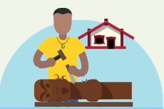
- Accommodate: Adjusting our places and practices to a changing climate, by restoring wetlands, adapting farming, or designing spaces to be future-proof.

- Protect places we love through action, such as preventing erosion, replacing concrete with nature and permeable surfaces, building swales to manage water.
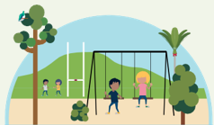
- Retreat: Develop a community vision for moving people, taonga and community assets to safe ground; contract expert help to investigate most challenging solutions.


